*Florida International University*

*School of Computing and Information Sciences*

Software Engineering Focus

Feature Document

User Story ID #971.2

**Name: Receive Notification**

**Team Member(s): Alvaro Silva**

**Project: SkillCourt**

**Product Owner(s)**: Guðmundur Traustason

**Mentor(s)**: Masoud Sadjadi

**Instructor**: Dr. Masoud Sadjadi

**Receive Notification:**

* Description: **As a** User **I would like** to receive notifications **so that** I can see that I received an invitation to play a multiplayer game.

Acceptance Criteria

* User has an account with SkillCourt

**Use Case**

* Name: Receive Notification
* Actor: Player
* Preconditions: Phone can receive notifications
* Description <Flow of events>:

|  |  |
| --- | --- |
| Actor Steps | System Steps |
|  | 1. System receives a notification. |
|  | 2. System displays notification in the notifications menu of the phone. |

**Use Case Diagram**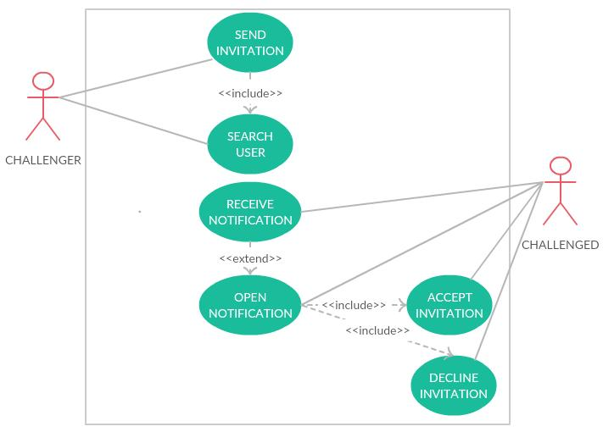

**Sequence Diagram**

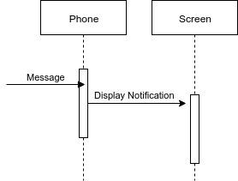

**Unit Test**

* Test case ID:
* Description/Summary of Test: Test if the implementation for receiving the notification for multiplayer mode works.
* Pre-condition: SkillCourt app running.
* Expected Results: Receives the notification.
* Actual Result: The phone receives the notification and display it in the Notifitation menu.
* Status (Fail/Pass): Pass.

**Visual User Guide**

